Performance as Remediation, where the concepts of
Immediacy and Hypermediacy converge

Telma João Santos

Introduction
In today’s modern societies, based on the use of the diverse available media, it is trivial to look at a picture on a screen of a computer, tablet, phone, etc. However, if we go back a few decades, this would just be a futuristic prediction from the universe of the not achievable, due to the lack of technology that would allow doing it. Many authors have produced knowledge in the field of how we relate to these platforms emerging at a breakneck pace, and how they have transformed the concept of image and communication, such as Jay David Bolter and Richard Cruisin, Lev Manovich, Henry Jenkins, and Christopher Steiner, among others. Thus, concepts such as Remediation, Immediacy and Hypermediacy have been defined, characterized and contextualized in the development of visual culture and of media and software studies.
In this article, we seek to develop an approach to the questions: “How can all these concepts be understood in the context of performing arts, particularly in Performance? Is it possible that Performance, whether or not based on the use of media, is nothing more than a process of Remediation, aspiring for Immediacy and based on Hypermediacy?” In a very real reading, we may see Performance as always based on processes of Remediation of concepts, places, media, possible readings, or concrete techniques, where Immediacy identifies in the desire to “touch” the public, and where media and platforms based on Hypermediacy are used, either because they are available and obvious as tools for the everyday use, or because they are used with the aim of triggering the participation of the audience in some active (or even passive) form.
The first part of this article puts forward some definitions and approaches to these concepts according to several authors and in different contexts. The second part considers these concepts in the context of Performance, a natural extension of their application, where the convergence of Hypermediacy and Immediacy is referred to. In particular, in the third part, these concepts are discussed using a concrete example, On a Multiplicity, presenting a body with multiple layers of self-representation, appealing here to the forms of self-representation so much employed, for example, in the use of social networks. The fourth and final section presents some final thoughts and ideas still up for exploration.

An approach to the concepts of Remediation, Immediacy and Hypermediacy
As technology, media and software have evolved, theoretical tools have become critical to a broader understanding of the forms of communication, sharing, and self presentation/representation in modern societies. In 1999, Jay David Bolter and Richard Grusin introduced terms such as Immediacy, Hypermediacy and Remediation to map and show that, as mentioned by the authors in (Bolter & Grusin, 1999), “our culture wants both to multiply its media and to erase all traces of mediation: ideally, it wants to erase its media in the very act of multiplying them”.
The concept of Remediation was introduced by Richard Grusin in an initial conversation with Jay David Bolter, as “a way to complicate the notion of repurposing, and then developed by both in three directions: a) as mediation of mediation: “each act of mediation depends on other acts of mediation” (Bolter & Grusin, 1999); b) as the inseparability of reality from its mediation: “mediation is the remediation of reality because media themselves are real and because the experience of media is the subject of remediation” (Bolter & Grusin, 1999); and c) as reform, restoration: “the goal of remediation is to refashion or rehabilitate other media. Furthermore, because all mediations are both real and mediations of the real, remediation can also be understood as a process of reforming reality as well” (Bolter & Grusin, 1999).
Thus, Remediation is defined here as the set of forms in which reality, media and software are being transformed, updated and reworked into new media and software, as well as the set of forms in which these new media and software are reformulated by older forms. J. D. Bolter and R. Grusin also argue, in (Bolter & Grusin, 1999), that Remediation processes do not have their origin in the digital era, and may be identified over the last hundred years in the Western visual representation: the Renaissance era, the (re)discovery of the linear perspective came to be Remediation of painting, and photography is Remediation of older forms and mechanisms of representation of real images, such as the camera lucida. In this sense, it may be asserted that Remediation is a term of the late twentieth/early twenty-first century that describes and characterizes a process with several hundred years.
The concepts of Immediacy and Hypermediacy are intrinsically linked to the concept of Remediation. Immediacy may be understood as the desire to make mediums transparent, to delete them, so that the content becomes “real”. Examples are interactive games, where the goal is to create environments that absorb the user, as well as virtual reality, where the disappearance of the medium is, indeed, the major objective. However, new media and software have been developed on platforms, where the use of multiple options of have access to diverse media is one of their features, and, hence, where Hypermediacy emerges as a logic of Remediation. A very simple example of Hypermediacy is a webpage where text, sound, photography and video may be accessed, as well as other related links, all making part of the same access platform. Seeming, at first glance, opposing concepts, Immediacy and Hypermediacy, indeed, converge: “the appeal to authenticity of experience is what brings the logics of immediacy and hypermediacy together” (Bolter & Grusin, 1999).
In this article, the concept of convergence is used in a broader sense than the convergence of Immediacy and Hypermediacy in processes of Remediation: it is one of the features of contemporary societies, as a result of the accelerated development of the diverse media, as well as the associated software. As Henry Jenkins argues in (Jenkins, 2006), “convergence represents a cultural shift as consumers are encouraged to seek out new information and make new connections among dispersed media” (Jenkins, 2006). Also in the same book, the author combines convergence with the participatory culture that characterizes these societies, i.e., “rather than talking about media producers and consumers as occupying separate roles, we might now see them as participants who interact” (Jenkins, 2006). Another way of convergence reported by H. Jenkins is the convergence of old and new media, which is surprising compared to the forecasts of the 1990s, when they were expected to generate collisions: “if the digital revolution paradigm presumed that new media would displace old media, the emerging convergence paradigm claimed that new media will interact in ever more complex ways” (Jenkins, 2006).
Therefore, convergence is a dynamic feature attributed to the ever changing contemporary world, where the software has become, as noted by Lev Manovich in (Manovich, 2013), “our interface to the world, to others, to our memory and our imagination, a universal language through which the world speaks, and a universal engine on which the world runs” (Manovich, 2013). Still in his latest book, Lev Manovich introduces the concept of software culture to refer to our contemporary society and, hence, also called software society: “our contemporary society can be characterized as a software society and our culture can be justifiably called a software culture, because today software plays a central role in shaping both the material elements and many of the immaterial structures that together make up ‘culture’” (Manovich, 2013).

Remediation, Immediacy, Hypermediacy and Convergence in the context of Performance
This section approaches the concepts of Remediation, Immediacy, Hypermediacy and Convergence in the context of Performing Arts, in particular Performance, their definitions, features and inter-relationships, allowing asserting that it is possible to characterize, in this context, contemporary culture as a culture of digital self-representation or media self-representation culture, associated with a digital society of self-representation or media self-representation culture.
Let us start with some approaches to the concept of performance. If we google the term performance, we find various definitions and meanings in different contexts, such as the context of sport, business, sex, education, art, etc. In all these meanings, except for the artistic meaning, this term is associated with a standard behavior, to which one is intended to match; conversely, in the artistic meaning, the term refers to the public presentation of a show, where areas such as music, dance, theatre, visual arts, multimedia, and so forth may be present.
In this article, focus will be placed in the context of art performance, in which a performance may be seen as any show where the consciousness of being sharing/showing something is present, although it is noted that the source of this awareness is the notion of performative action as part of the daily social behavior of the human being, as referred by Erving Goffman in (Goffman, 1959): “the legitimate performances of everyday life are not ‘acted’ or ‘put on’ in the sense that the performer knows in advance just what he is going to do... But [this] does not mean that [the person] will not express himself... in a way that is dramatized and performed”.
We are, thus, interested in the concept of performance as defined by Marvin Carlson in (Carlson, 2011), i.e., as a show where “its practitioners do not base their work on characters previously created by other artists, but on their own bodies, on their autobiographies, on their specific experiences in a given culture or in the world, that become performative in that practitioners are aware of them and exhibit the before an audience”, or by RoseLee Goldberg in (Goldberg, 2012), as a work that may “take the form of a solo or group show, with lighting, music, or visual elements created by the performer him/herself or in collaboration with other artists, and be presented in places such as an art gallery, a museum, an ‘alternative space’, a theater, a bar, a cafe, or a corner”.
Given that we intend, in this section, to contextualize some concepts derived from media and software studies, we also consider new perspectives and challenges that new technologies bring and that propose expanding boundaries in the context of performance, as stated by Barbara Kirshenblatt-Gimblett in (Kirshenblatt-Gimblett, 2004): “Performance as an organizing idea has been responsive not only to new modes of live action, but also new technologies... [We need to] take issue with the assumption of human agents, live bodies, and presence as organizing concepts for Performance Studies... If boundaries are to be blurred, why not also the line between live and mediated performance?” Concerning breaking down barriers and definitions in the context of performance studies, we may go further and agree with Richard Schechner, when the author states in (Schechner, 1998) that “Performance studies is ‘inter’ – in between. It is intergenric, interdisciplinary, intercultural – and therefore inherently unstable. Performance studies resists or rejects definition. As a discipline it cannot be mapped effectively because it transgresses boundaries, it goes where it is not expected to be. It is inherently ‘in between’ and therefore cannot be pinned down or located exactly. This indecision (if that’s what it is) or multidirectionality drives some people crazy. For others, it’s the pungent and defining flavor of the meat”.
In this article, we also distinguish performance, which, as we have seen, may be defined in the light of several approaches, but which is associated with an act of showing/sharing, of Performance (Studies/Art), and this is the area of study and artistic creation where the performance itself is one of its constituent parts.
In the first decade of this century, with the emergence and development of search engines, blogs, instant messaging programs, and platforms such as iOS, Android, Facebook, Windows and Linux, hundreds of millions of people have introduced all these tools on their daily lives, giving rise to new forms of presentation and representation of themselves. Thus, we may look at contemporary society as a society of digital self (re)presentations, which activities initiated on social networks, forms of editing oneself on several platforms of (re)presentation, are an intrinsic part its characterization.
The (Art) of Performance is one of the areas where forms of self-presentation and self-representation have been studied, questioned, and publicly presented so as to provide us with a “state of art” of society in a specific cultural context, on a specific date. In general, performers have used new media and latest software in different directions and at different levels, from simply using email lists and social networks to publicize the work, to sharing photos and videos of rehearsals and/or final performance and/or interviews with actors/performers, to using video performances – in real time or edited – within the performance, to presenting performances using various mediums, one of them the live streaming, to exclusively online performance festivals. The sharing of material throughout the process that allows the use of feedbacks in the construction of the work itself is a feature of this development, as well as blogs of opinions and discussion of plays after their public presentations. Some concepts and models of thought have been introduced in Performance Studies, such as the Rhizome, a concept introduced by Gilles Deleuze and Félix Guattari in (Deleuze & Guattari, 2008), where the authors present an epistemological system based on the idea that knowledge develops from all points that arise from observations and conceptualizations, and, therefore, a network. Moreover, the several research studies in neuroscience have brought huge results with the development of hardware and software that have also allowed introducing some knowledge regarding the body-mind relationship(s) (see e.g. (Damásio, 1994) and (Damásio, 2010)). In parallel, with the development of new media and software in Performance, concepts such as Remediation, Immediacy, Hypermediacy and Convergence have also to be defined and reinterpreted in this new context. Considering the diverse types of relationship established between performance and new media and software, it may be stated that, in Performance, Remediation may be characterized by the set of ways in which the reality and the media and software are being transformed, updated and reformulated in the context of Performance and in which Performance is also being transformed, updated and reformulated in its different aspects. Regarding the concept of Immediacy, we observe that, even though there is some kind of distance between the performer and the audience, there is an implicit desire to “touch” the spectator, to make him/her/them feel the performer(s). At the same time, Hypermediacy is part of the performance, in the sense that it unfolds at least in several media representations of itself in its dissemination. Thus, Immediacy and Hypermediacy also converge in Performance, in a more concrete way when we watch performances that explicitly use media and software in the final object and, in a more implicit way, when performance only uses media and software in the construction or dissemination process.
We have a new challenge ahead regarding what new media and software have brought to Performance: how to jump from a convergence culture, where dispersed information converges to a broader understanding, to a self media (re)presentation culture, where people relate and communicate on a personal level, and that communication is grounded on self-representations based on media and quotes from others and that map our social activities, and also where convergence is characterized by collections of self-representations that are interpreted as a whole, and specifically contextualized in space and time.

On a Multiplicity, a practical exemple of multi visual self-representation as performance
On a Multiplicity is a project in which I was involved in late 2010, when I decided to film myself regularly and for about a year, improvising movement in defined and restricted spaces in each of three houses where I lived throughout that year, and at the end of at least five hours of study related to the PhD in Mathematics – Calculus of Variations – which I finished in December 2011. Thus, between December 2010 and September 2011 I made video recordings of motion improvisations – which I called Improvisations Series – using various movement techniques, such as Laban, techniques of real-time improvisation and composition, Performance techniques, and where the work carried out in the lab Being Present/ Making Present, supervised by Nicole Peisl (Forsythe Company) and Alva Noe (University of California-Berkeley), in August 2010, Frankfurt, became essential in building vocabulary. An important rule in these records: they were made immediately after at least five hours of study related to my PhD thesis, and, in particular, to the research of new theoretical results on the Strong Maximum Principle in the context of the Calculus of Variations.
In a first stage of the process, the main concern was the rigor used in the compliance with the pre-self-established rules: to have a specific space of the house previously defined, to have studied mathematics in the context of the PhD thesis, and have an interval no more than 10 minutes long between the end of the study and the video recording.
Meanwhile, I edited the videos, analyzing theoretically possible meanings, which I shared using social networks, and reformulated video-editing and other possible formats for public presentation. I also decided to record in video and sound the verbalization of the research I was developing in the Calculus of Variations, as well as some thoughts on this particular future performance.
In its final form, On a Multiplicity was presented as a performance/installation, where real-time improvisation is combined with video and sound projection as the thesis of the research study I carried out throughout 2011 and 2012.

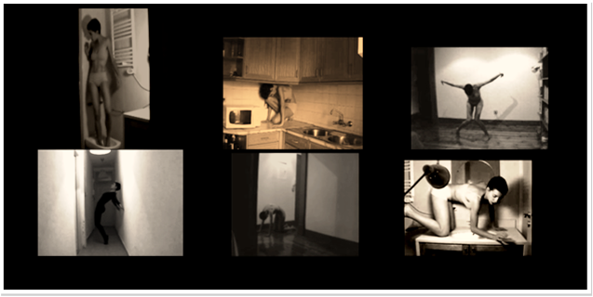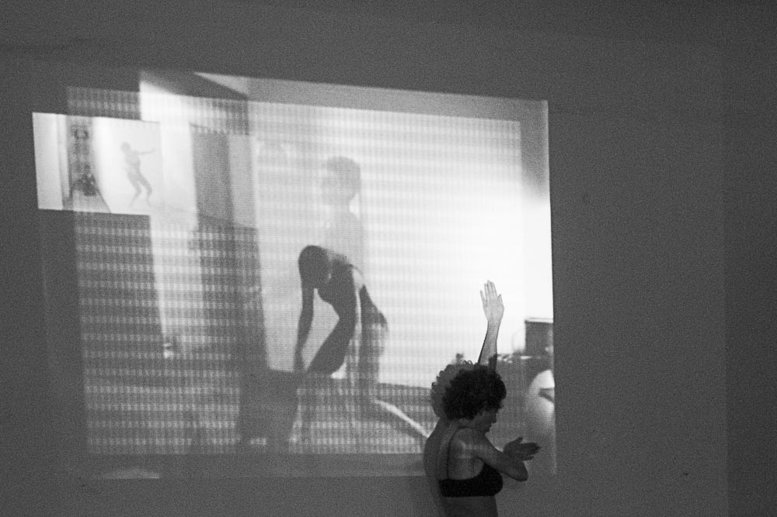
Photography on the left: frames of the initial video recordings
Photography on the right: performance/installation on the
JazzyDanceStudios, December 8, 2012, in Lisbon

That is, in On a Multiplicity, these videos were projected simultaneously with audio of attempts to explain the concepts used in mathematical research, as well as some of the concepts covered in building performance and resulting from some literature research on visual cultures and performance, and also real time improvised movement, in an attempt to present a multiplicity of self-representations where mathematics and performance intersect and integrate.
This performance/installation may be envisaged as a concrete example of Remediation, Immediacy, Hypermediacy and also convergence, as one of its main features is the use of various mediums, so as to address environments between mathematics and dance, as well as to create multiple layers of those environments throughout the process, where the body in real time is the element of the relationship with itself in its various representations, and which is clearly a process of Remediation. YouTube and Facebook were also used, with the purpose of sharing material, and a personal webpage was also built for organizing research, where the concept of Hypermediacy is present quite explicitly. Yet, the desire of Immediacy is, in this proposal, rather concrete, where the intimacy with the spectator is the convergence of this desire for closeness with the multiple self-representations projected.

Conclusion
In this article, concepts such as Remediation, Immediacy and Hypermediacy were introduced in the context of Performance; moreover, a concrete example of a performance/installation, On a Multiplicity, was also presented, which is, in essence, a multimedia installation associated with the concept of self-representation as a form of communication, and with real time improvised movement. In the first part, these concepts were introduced in the context of media studies, as well as the relationships between them. In the second part, these same concepts were introduced, but, in a process we may consider of Remediation, they were contextualized in Performance studies. In the third part, the performance/installation On a Multiplicity was, then, presented, as an example of application of these concepts.
There are plenty of open issues in what concerns the development of new media and software in their relations with Performance, and other issues emerging with a speed that is proportional to that same development, given that, as we know, changes are continuous, which produces continuous reactions and remediations in the diverse areas that make up contemporary society. One is how to deal with new audiences who are sitting but not present in the concrete, and who watch a performance through a screen, in the sense that, in classic terms, a performance is understood as a relationship established in real time with the audience, associated with a concept or idea, and through certain concrete actions? Obviously, in this new context, the concept of performance has to be rethought, or remediated, so that it may be possible to find structures of thought on methodologies of performances’ construction in our days.

References
Bolter, J. D., & Grusin, R. (1999). Remediation - Understanding New Media. Cambridge: The MIT Press.
Damásio, A. (1994). O Erro de Descartes - Emoção, Razão e Cérebro Humano . Lisboa: Publicações Europa-América.
Damásio, A. (2010). O Livro da Consciência-A Construção do Cérebro Consciente. Lisboa: Temas e Debates.
Deleuze, G., & Guattari, F. (2008). Mil Planaltos - Capitalismo e Esquizofrenia 2. Lisboa: Assírio & Alvim.
Jenkins, H. (2006). Convergence Culture - where old and new media collide. New York: New York University Press.
Noe, A. (2002). Is the Vsual World a grand Illusion? Journal of Consciousness Studies , 9 (5/6), 1-12.
MacDougall, D. (2006). The Corporeal Image: film, ethnography and the senses. Princeton: Princeton University Press.
Manovich, L. (2013). Software takes Command. New York: Bloomssbury Academic.
Spry, T. (2001). Performing autoethnography: an embodied methodological praxis. Qualitative Inquiry , 7 (6), 706-733.
Steiner, C. (2012). Automate This - how algorithms came to rule our world. NEW YORK: PORTFOLIO/PENGUIM.
Russel, C. (1999). Auto Ethnography: Journeys of the Self. Durham: Duke University Press.
Reed-Danahay, D. (1997). Auto Ethnography: Rewriting the Self and the Social. New York: Berg.

Repurposing is herewith referred to as “the use of the same content across different media forms” (Bolter & Grusin, 1999).
An example is the recent work of the director João Garcia Miguel, where multiple platforms of creating, editing and exhibition of video and sound in real time have been explored within the works.
We have the Festival Verão Azul, in Lagos, as one example in Portugal of a festival presented live and in live streaming.
As an example, we have the Upstage Festival of Cyberformance.
I recall a recent discussion – late August / early September 2013 – on various blogs and social networks relating to the “Art Piss” performance by the double Ana Borralho & João Galante, where performers urinate over money and photos of politicians around the floor. Some people were quite shocked by a video of the performance, stating that this kind of work is not art and they should not be subsidized by the Portuguese state, among other moralist arguments, and may be regarded as a mirror of our 2013 cultural, economic, social and political context.
Here, “some sort of distance” refers to any technique that aims at creating the perception in the public that it is an observer in the context of the performance in question.
Considering the use of social networks and mailing lists for the dissemination of performance as the minimum level of media and software uses.
Some elements of the research process and of some public presentations are available at http://www.telmajoaosantos.com, in the section concerning performances.
This PhD thesis, entitled Some version of the Strong Maximum Principle for elliptic integral functional, is available at http://www.telmajoaosantos.com. One of the results from this thesis was published as an article and is available at http://link.springer.com/article/10.1007%2Fs11228-011-0176-x.
Here I refer to the improvisation techniques seized and developed in the Contemporary Dance Company of Évora, following the Laban Improvisation Technologies, as well as the technique of Real Time Composition of João Fiadeiro, being the latter a basis for the construction and the former elements of disturbance, in order to establish relationships and commonalities.
Here I refer to the construction of images, as well as techniques of democratization of the Creative process from Guillermo Gomez-Peña and his group, La Pocha Nostra, as well as some elements of Works from Margarida Mestre, Mário Afonso and Esther Ferrer.
In this project, I studied, particularly, authors connected to visual self-ethnography, such as Tami Spry (Spry, 2001), Catherine Russel (Russel, 1999), Deborah Reed-Danahay (Reed-Danahay, 1997), as well as those connected to the study of visual perception, such as Alva Noe (Noe, 2002), or to the study of emotions in the context of anthropology, such as David MacDougall (MacDougall, 2006).
https://www.youtube.com/user/freakytoruffini.
https://www.facebook.com/TelmaJoaoSantos.

