 | 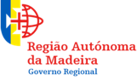 |  |  |  | 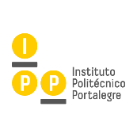 | 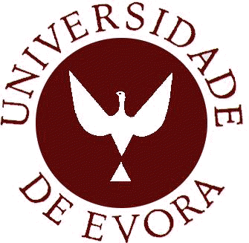
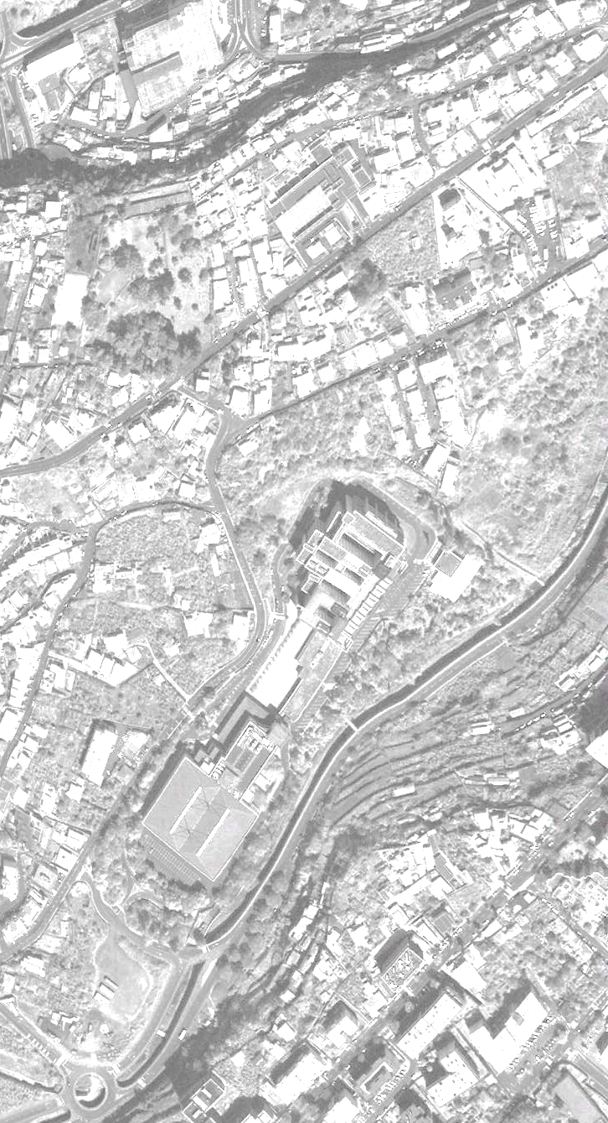

I INTERNATIONAL CONGRESS ON SUSTAINABLE PLANNING AND TERRITORIAL GOVERNANCE

Faculty of Exact Sciences and Engineering (FCEE), Department of Civil Engineering and Geology (DECG). University of Madeira (UMa), Funchal, Portugal
4 - 5 - 6 June 2018

Title  (paper) | Potential vegetation: contribution to urban planning
Abstract  (summarize the problem and objective of your paper and refer the method, results, conclusions, future research directions, etc.;  length: 200 - 250 words) | The introduction of potential vegetation in the urban space is fundamental in the cities identity and in the intensification of ecological efficiency. Given the contemporary city challenges it’s urgent a sustainable solution that reduces the maintenance and the energy input. Its utilization, as part of a landscape structure in the urban space, is framed on the contemporary city strategy which must: promote wellbeing, be sustainable, be resilient and adaptive facing future uncertainty, namely climatic changes.  Considering the contemporary city sustainable planning and recent studies on urban spaces, ecological systems and their aesthetical values, this project is based on a bibliographical review of theoretical studies about the themes we seek to develop. The aim of this presentation is the inclusion of potential vegetation in a new design approach to the city's open spaces. It is defined by the ecological systems, working with the site ecological conditions, aiming at improving the efficiency of multifunctional land uses (production, protection and leisure). This design approach simultaneously ensures the articulation of these spaces with urban interfaces bringing the natural processes near to the "urbanscape". This will enhance protection to sensitive areas and, as added value, increase biodiversity and recreational fruition of these different landscapes. The linkage with nature and identity is also promoted, improving the wished sense of identity and belonging.  The main outcome of this proposal is the design of a landscape infrastructure in the city of Évora that assures the articulation with its open spaces and the connection between them and the countryside.
Key-words  (4 - 5 words) | Cities identity; ecological systems; sustainability; biodiversity
Author(s) name  (name - surname) | Catarina Carvalho ⁽²⁾  Rute Matos ^{(1, 2)}  Conceição Castro ^{(1, 3)}  Carlos Pinto-Gomes ^{(1, 3, 4)}
If the paper is co-authored, indicate the author or authors that will be present (physical presence requires registration) | Catarina Carvalho  Rute Matos  Conceição Castro  Carlos Pinto-Gomes
Institutional affiliation  (department, university, research centres or similar) | (1). Departamento de Paisagem, Ambiente e Ordenamento, Escola de Ciências e Tecnologia, Universidade de Évora, Portugal /Department of Landscape, Environment and Planning; School of Science and Technology. University of Évora-Portugal  (2). Centro de História da Arte e Investigação Artística (CHAIA)/Center for Art History and Artistic Research  (3). Instituto de Ciências Agrárias e Ambientais Mediterrânicas (ICAAM)/Institute of Mediterranean Agricultural and Environmental Sciences  (4). Instituto de Ciências da Terra (ICT)/Institute of Earth Sciences
Position  (Prof., Dr., Post doc, PhD Student, etc.) | - PhD student  - Prof.  - Prof.  - Prof.
Postal address  (postal address of your institution) | (1,3). Apartado 94, 7006-554 Évora- Portugal  (2). Palácio Vimioso, Largo Marquês de Marialva nº 8, 7000-809 Évora-Portugal  (4). R. Romão Ramalho, 59, 7002-554 Évora-Portugal
Electronic address  (e-mail address) | - d11461@alunos.uevora.pt  - rsm@uevora.pt  - mccastro@uevora.pt  - cpgomes@uevora.pt

