Greenways – an alternative mobility structure and an urban development strategy

Rute Sousa Matos and Rita Calhau
University of Évora
Art and Art History Investigation Centre (CHAIA) -
University of Évora
Évora, Portugal
rsm@uevora.pt
rita.clh@hotmail.com

Alexandre Lisboa
Oeiras City Hall
Green Spaces Department
Oeiras, Portugal
alexandre.lisboa @cm-oeiras.pt

Abstract— Greenways are fundamental in establishing a continuous landscape structure. This landscape structure involves natural and cultural factors that determine flows and processes both at the ecological level, both social and aesthetic.
Within the extensive range of functions that green corridors play, one should highlight the implementation of an alternative mobility structure enhancer of natural and artificial flows in the landscape. We intend to establish a strategic plan implemented through a sustainable structure, enabling to effect the flows and processes referred to in a context of natural and cultural continuity, enhancing the landscape values which is going through, giving a balanced soil occupancy considering the potential of each area faced with fast current urban growth.
Our main objective is then the application of the concept of "greenway" in the municipal ecological structure, by proposing a network of corridors and the subsequent definition of different types and proposals, according to their respective potential. This aims to protect the values ​​and natural resources, as well as forestry, agricultural and cultural areas as well as the respective integration of key systems for environmental protection and the enhancement of rural and urban areas. It is intended that they act as continuous landscape structures ensuring the multifunctionality of ecosystems and of landscape.
The case study presented is the municipality of Oeiras, District of Lisbon. Portugal.

Keywords- Greenways; continuous landscape structure; landscape multifunctionality

Introduction
This paper is the result of a study that has sought strategies for the implementation of a network of greenways in the municipality of Oeiras, in the metropolitan area of Lisbon, in Portugal.
The proposed work is based on a network of greenways coordinated with the municipal ecological structure, and takes various forms depending on the biophysical, social and cultural characteristics essential to it. The purpose of this joint structure, ecology/mobility, is to protect the values and natural resources, and forest, agricultural and cultural areas, as well as to integrate the systems essential to environmental protection and enhancement of rural and urban areas.
The first part of our study addresses the concepts of alternative mobility and of greenways, and then tackles the analysis, interpretation and characterization of landscape. The analysis and framework of the Oeiras council backdrop covers: its historical and geographical context, the characterization of its landscape, its coordination with Agenda 21, and the implementation of the council’s Municipal Master Plan (PDM), which is the legislative basis for setting out the main rules on the council’s land use planning.
Following this characterization, we diagnosed in situ both the layout of existing alternative mobility and of the municipality’s ecological structure, comparing both and seeking to find potential links and common features.
Based on this diagnosis, we have defined different types of existing greenways, including those of an ecological and social nature that are vital for proper land use planning, which is central to sustainable development.
The second part of our study presents a few proposals for the different types of greenways found.
The information and data provided in this paper concerns only the greenways, particularly in respect of the objectives and strategies adopted, the definition of their various types, and the proposals found for each of them.

Material and Methods
The issue discussed here, including the concept of greenways, the objectives and strategies adopted, in which we now include a strait relation with landscape, led to a discussion by various authors (since twentieth century), thus producing critical studies and works on its relevance. The authors that interest us are the ones that considered the relation between green corridors and landscape as an area of vital experience, both in terms of an ecological and social dimension which should be inherent in the city planning.
This article is then developed based on the literature review on theoretical studies produced on the issue that we aim to develop. We will also study Oeiras green corridors and landscape and the work that has been developed to include them in the urban planning, in terms of its social, economical, ecological, cultural, ethical and aesthetical dimension.

Discussion

Greenways
The greenway movement is the end result of a planning strategy begun in the early 19th century, not idealized by one single author but rather by a number of individuals and the result of personal efforts that for almost a half a century gradually consolidated and expanded an idea [1]. Although the concept of greenway has existed for more than three decades and its relevance for the green urban structure is well known, no clear reference can be found in Portuguese legislation. Reference is only made to a continuum naturale as a continuing system of natural events in the basic environment law, omitting its social and cultural relevance [2]. The national sustainable development strategy [3], however, more specifically the 5th objective – better international connectivity of the country and balanced enhancement of the land – refers to the support to investment to be made in individual cities, to strengthen the sustainability of their operation, including the support to the creation of greenways and “green” public spaces in the cities, as the fundamental investment for the improvement of their environmental quality. One could say that there is already some ecological concern about the greenways.
In the 1990s, [4] compiled a broad range of definitions of greenway, which has counteracted the tendency to exclusively assign ecological functions to the greenway. Little refers to these greenways as connectors of fragments of natural ecosystems in urban sites, and mentions also their potential for recreational and leisure uses, and as an alternative mobility system.
Today, and in line with the strategic plan of greenways [5], the Municipal Council of Oeiras defines a greenway as an alternative mobility structure capable of generating natural and artificial flows within the territory. It is characterized by being a system or a single network with spaces contextualized according to their type and arranged hierarchically, based on a principal or secondary green structure of a territory, that is, on natural sites or built sites. [6]
As part of the review of the Master Plans, priority should be given to the development of several proposals contributing to the expansion of the ecological structure, coordinating, as much as possible, the different existing sites. In the review of the 1994 Master Plan, a preliminary study was prepared on the potential layout of a network of greenways for the municipality of Oeiras. In this study, the greenways have two different sets of functions that need to be taken into account in this project: ecological functions, linked to living beings and the environment, and social functions, linked to culture, recreation and leisure.
- Overall objectives and strategies adopted
Based on the analysis and characterization studies carried out, the following were defined as the main objectives of the strategic plans for greenways:
- Implement a sustainable structure covering the entire municipality to achieve a number of functional and ecological flows in a continuum naturale context.
- Coordinate the municipality’s green structure with an alternative mobility network. Other benefits of the greenway connectivity include alternative forms of transport, recreation, and the need or preference for a relationship of proximity with nature.[7]
- Enhance the natural and intrinsic value of landscapes crossed by these greenways; the integration of cycle or cultural routes with the ecological structure adds value to both structures and promotes their acceptance [8]. However, there is also the intrinsic value of the typical landscape features to consider; in this particular case, the many watersheds and enclosed valleys that offer unique views.
- Ensure the balanced occupation of the area bearing in mind the purpose of the spaces and the current rapid urban growth: the implementation of the greenway concept has gained in popularity abroad in response to climate, cultural and political changes and to proliferation factors [9]. Economic decentralization and urban expansion have raised much interest in planning models and alternative methods, as their physical links offer distinct advantages as regards the circulation and transport of materials, species and nutrients, besides being a network of social development that draws people with different values and perspectives about land use and planning. This is perhaps the most striking characteristic of greenways setting them apart from other spatial planning concepts [10].
The strategies adopted to date are divided into four distinct phases:
- Propose an overall municipal structure.
  - Integrate planning with other services of the Municipal Council of Oeiras (CMO) for specific areas.
  - Implement sector-specific projects integrated in the structure.
  - Prepare work according to studies and projects.
According to these strategies and with the objectives mentioned above, work was carried out in all phases, especially along the existing waterways. The Green Space Department (DEV) submitted the Landscape Rehabilitation Project for Streams in the Council of Oeiras (PRPRCO) in 2011. The strategic purpose of this project was to define a series of activities for the rehabilitation of streams and surrounding areas, paying particular attention to them as specific ecosystems, improving their environmental and landscape quality and, at the same time, militating against the idea that they are unattractive and not very accessible places, rather declaring them as connecting channels between the municipality’s inland and coastal areas [11]. In this study, the PRPRCO was considered an integral part of the greenway strategic plan. The rehabilitation of streams and surrounding areas was, in itself, a strategy of intervention, assumed as such in our work. This type of work required profound knowledge of the places needing intervention, which is why we arranged for field trips to give us an exact idea of what was needed and the solutions that had to be worked out. These trips were vital for correcting the types and layouts of greenways. We then defined four different types of greenways, identified in fig. 1.

- Greenways associated with waterways
In a first tentative outline of a greenway network, the first lines to be drawn have to be the waterways as they are preponderant in the landscape. These waterways formalize the corridors most sought after for outdoor leisure purposes. So, where possible, there have to be connections along the waterway and contact points with natural resources and landscapes, and with cultural and historical values [5]. These waterways are mostly linear and boast unique hydrogeological, hydrological, geomorphological, flora and fauna features, contrasting with the matrix or surrounding landscape [12].

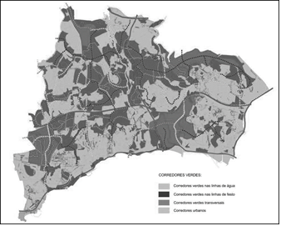
Figure 1. Greenways strategic plan, (source: www.cm-oeiras.pt)
The streams in the municipality have always been part of this territory and have become important points of reference due to
their amenity, clear flowing waters that served to irrigate farms and surrounding fields, and crossed the urban settlements, contributing to the quality of landscape [13]. These are precisely the experiences and natural values that this study seeks to restore. According to [4], waterways are an important resource for the maintenance of species and are, therefore, important for their preservation and management. The existing streams in the area under study can potentially become waterways and be entitled to landscape rehabilitation. This is why they have become a priority in both our study and in the context of future sustainable interventions in the municipality.
The hydrological regime of waterways is of the torrential type. During significant parts of the year, the flow is either very low or non-existent, but during heavy rainfall surface run-off flows are quite fast and give rise to very high stream flows. To study this type of waterway we overlapped the outline of waterways in connection with the biophysical analysis with the orthophotomap and conducted field trips to each stream: Ribeira da Laje, Ribeira de Porto Salvo, Ribeira de Barcarena, Rio Jamor and Ribeira de Algés/de Outurela.
- Greenways associated with watersheds
Watersheds define the water basins as these lines mark the division of water down the slopes. If we stand in a lower altitude area, these watersheds represent the highest relief and limit our visual coverage. Similarly, greenways associated with watersheds are intended to connect the urban and rural spaces, crossing the most significant natural and heritage elements in the municipality. They should somehow connect native vegetation and maintain biological diversity and ecological balance, playing an important role in nature conservation [4]. The most appreciated characteristic of this type of waterway is the visual coverage along the routes, as in journeying along these raised paths the view over the sea and river is quite extensive [5].
Most of these waterways can be found in the northern half of the municipality of Oeiras. Note the high altitude watersheds – standing at 100 and 200 meters high – located on the northwest and northeast boundaries.
- Uninhabited connecting greenways
According to the strategic plan for greenways, connecting corridors are used to connect all corridors [5]. We chose to base our approach on two different types of connecting greenways which cement the idea of the municipality’s network of greenways: connecting greenways in uninhabited areas and connecting greenways in populated area. As regards the former, emphasis will be given to connections between watersheds and waterways and/or between two waterways. In respect of the latter, their purpose is to interconnect the urban centers and/or a greenway and an urban center. We dealt with in particular with corridors in uninhabited areas and took into account all corridors formed by open spaces in unbuilt areas. They are clearly for recreational use as, wherever possible, they allow a direct connection with open recreational and leisure sites and with natural sites. In addition to scaling up the development of leisure, sports and recreational activities, this type of corridor enables the significant improvement of climate conditions by regularizing temperature, radiation, atmospheric pressure, wind and humidity, and also improves air quality by purifying and controlling air pollution, preventing and reducing the risk of flooding and soil erosion, and increasing the typical biodiversity of green urban areas.
To arrive at this typology, we cross-referenced data on the greenway network route for the proposal to review the Master Plan in force with the tree register and the classes of the National Agricultural Reserve areas (RAN) and of the National Ecological Reserve (REN) contemplated in the Master Plan in force.
- Populated connecting greenways
As mentioned in the previous typology, if uninhabited connecting greenways refer to watersheds and waterways and or/ between two waterways, populated connecting greenways focus on the coordination of urban centers. They reflect the improvement made in the structure of urban areas, the increase of direct benefits, for e.g., the increase in value of existing buildings close to the rehabilitated green areas, and the increase of indirect benefits, for e.g., the production of oxygen and the reduction in energy consumption as a result of improved climate comfort. These are the corridors most likely to promote mild mobility, for e.g., cycling, in urban centers as an alternative to commuting, and the ones that contribute the most to the increase of vegetation in the urban landscape. Their scope is, however, more limited, consisting mostly of proposals for tree alignments, most of which coincide with the communication routes in urban centers.
To arrive at this typology, we cross-referenced data on the greenway network route for the proposal to review the Master Plan in force with the tree register and the classes of buildings contemplated in the Master Plan in force.

Proposals-Type
- Greenways associated with waterways
Interventions in waterways must include cleaning and environmental rehabilitation of river banks, and urban regeneration for the benefit and sustainable fruition of natural, social and economic systems. Built structures in the watercourse and in areas part of the floodplains (fig. 2), many of them illegal, are significant contributors to the increased likelihood of annual flooding, so their demolition should be considered in the long term.
Once the existing streams in the municipality are rehabilitated, they will interconnect the architectural, cultural and natural heritage bordering them (fig. 3). This has its advantages in the regeneration of the riparian area, creating opportunities for social and economic development compatible with the sensitivity of the natural system in question.
The rehabilitation of waterways is a good means to promote forms of sustainable mobility, as they form five north-south axes and will enable the connection of urban centers with existing commerce, services and public transportation. The latter include the existing large scale railway line along the south coast of the municipality, connecting the Lisbon, Oeiras and Cascais municipalities and increasing their tourist attraction.
Intervention works should be based on:
- The redefinition of the natural look of riverside beds, by bringing down all stone or concrete walls delimiting them and without any sort of aesthetic or cultural value;
- The redefinition of the floodplain area, in the long term;
- The definition of walkways and bikeways forbidden to road traffic, with a permeable surface suited to be near waterways;
- The creation of relaxation and support areas along the walkways, such as shaded areas, picnic parks and bicycle rental and parking;
- The creation of parking spaces at the far ends of these walkways to enhance their use;
- The promotion of tourism related to existing heritage elements;
- The redefinition of existing community gardens;
- The maximum usability of buildings in the surrounding areas for the management and support to cycle routes;
- The better fit of equipment within the landscape;
- Signage and information guide on the routes.
- Greenways associated with watersheds
Intervention works in greenways in the watershed can take full advantage of their nature conservation potential, by increasing the native vegetation patches and the biological diversity and ecological balance (fig. 4).
Once rehabilitated, high altitude areas in the municipality will be much in demand as they offer wonderful views and good weather conditions (fig. 5).

Figure 2 – Section of the existing streams.


Figure 3 – Section of the proposal.



Figure 4- Section of the existing watersheds

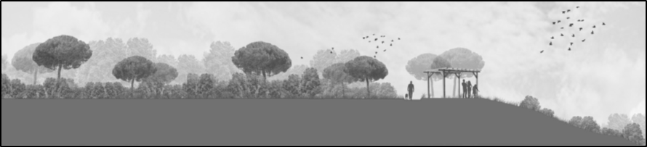
Figure 5 – Section of the proposal.
Intervention works in this type of corridor should be based on:
- The increase of the ecological structure used by the public, contributing also to avoid the urban sprawl;
- The protection of natural heritage with a view to a balanced and sustainable development;
- The promotion of better contacts between the population and nature;
- The improvement of landscape quality;
- The definition of walking and cycling trails, closed to road traffic, using a permeable surface suited to walking and the flow of surface water, and the creation of designated spaces for relaxation and support to walking trails, for e.g., shades areas, picnic park, and bicycle rental and parking;
- The creation of alternative uses with the potential of enhancing the use of areas, such as belvederes;
- The creation of more educational and environmental protection activities to increase participation and the exercise of citizenship; for example, the creation of environmental education activities for school children, e.g., plantations and education on the importance of vegetation and preservation of natural sites in urban areas.
- Uninhabited connecting greenways
As connecting routes in uninhabited urban areas (fig. 6) provide access to the surrounding open areas, they offer rather pleasant outdoor off-road trails allowing hikers to learn about the existing rural or farming landscape (figs. 7 and 8).
The advantages of these intervention works are as follows:
- Increase the development of leisure, sports and recreational activities;
- Improve weather quality by regularizing temperature, radiation, atmospheric pressure, wind and humidity;
- Improve air quality by purifying and controlling air pollution;
- Prevent and reduce the risk of flooding and soil erosion;
- Increase biodiversity in urban green spaces.
- Populated connecting greenways
Intervention works in this type of greenways (fig. 9) contribute essentially to increase vegetation in the urban landscape through the rehabilitation of pedestrian walkways (fig. 10) and proposing new tree alignments along the idle of roads and alongside walkways (fig. 11).
The advantages of these intervention works are as follows:
- Improve the structure of urban areas;
- Increase direct benefits, for e.g., increase the value of existing buildings located close to the rehabilitated green spaces;
- Increase indirect benefits, for e.g., the production of oxygen and the reduction in energy consumption as a result of improved climate comfort.


Figure 6 – Section of the existing greenways in green spaces.

Figure 7- Section of the proposal

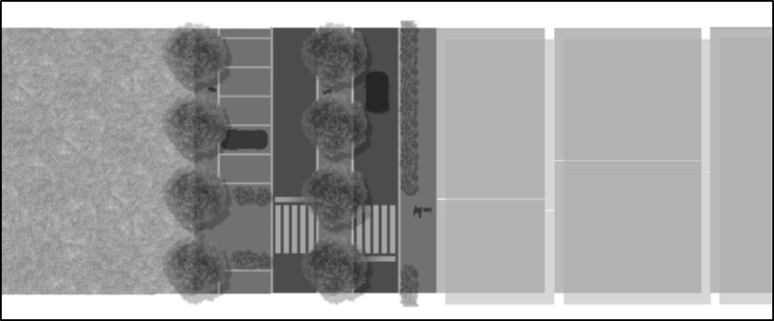
Figure 8 – Proposal plan of linkage axes in green spaces.


Figure 9 – Section of linkage axes in built areas


Figure 10 – Section of the proposal

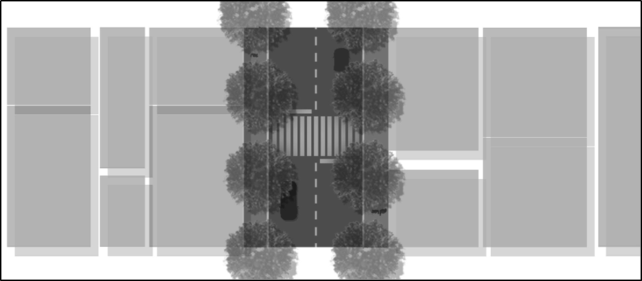
Figure 11 – Proposal plan of linkage axes in built areas.

conclusions
The existence of a network of greenways is very important on account of the advantages and unique ecological, social, economic and aesthetic improvements. Today, the impact of greenways all across the world is quite positive on the social well-being of populations they affect directly and indirectly.
In respect of the environment, greenways contribute to the improvement of climate quality by regularizing temperature, radiation, atmospheric pressure, wind and humidity; to the improvement of air quality by purifying and controlling air pollution; to the improvement of acoustic environment and road safety by using vegetation to absorb noise and avoid dazzle caused by oncoming traffic; to the prevention and reduction of the risk of flooding and soil erosion, and to the increase of biodiversity.
Socially-wise, they increase the development of leisure, sports, recreational and educational activities; they allow cultural outdoor activities, shows, workshops; they are part of the urban design composition, contributing to the organization and definition of spaces and to the scenic beauty of landscapes, in contrast with the artificial inert elements.
In respect of the economic sector, greenways reflect the improvement in the overall organization of the territory; the improvement of the urban area structures; the increase of direct benefits (vegetation used for production, increase in the value of built heritage close to the green areas, creation of jobs for maintaining these green areas), and the increase of indirect benefits (production of oxygen and reduction of energy consumption by improving climate comfort).
In the specific case of Oeiras, the review of the Master Plan is a clear opportunity for assessing the current spatial planning strategies, to develop and safeguard all future activities, even at a broader scale, including the implementation of a greenway connecting the Monsanto Forest Park and Sintra Mountain across Carnaxide Mountain. This connection further strengthens the purpose of this project, as it is an opportunity for spatial planning and urban development at regional level.

References

[1] Ramalhete, F. et al. Geota. Corredores verdes - conceitos base e algumas propostas para a área metropolitana de Lisboa. Lisboa: Grupo de Estudos de Ordenamento do Território e Ambiente.2007.
[2] Lei n.º 13/2002, de 19 de fevereiro de 2002, diário da república. I série a - n.º 42: 1324-1340.
[3] Resolução de conselho de ministros, n.º 109/2007, de 20 de agosto de 2007, diário da república. Série i - n. º 159: 5405-547
[4] Little, C. E. Greenways for America. Baltimore and London: The John Hopkins University Press. 1990.
[5] Câmara Municipal de Oeiras. Plano estratégico dos corredores verdes. Plano de desenvolvimento estratégico. Oeiras: Câmara Municipal de Oeiras. 2005.
[6] Câmara Municipal de Oeiras. Relatório de atividades/resultados/estratégia. Documentos anexos plano estratégico. Oeiras: Câmara Municipal de Oeiras. 2006.
[7] Kaplan et al. referred in Ahearn, J. Greenways in the USA- theory, trends and prospect. Cambridge: Cambridge University Press. 2004
[8] Magalhães, m. R. Estrutura ecológica da paisagem, conceitos e delimitação - escalas regional e municipal. Lisboa: Isapress. 2007.
[9] Ahern, J., Fabos, J. A global greenway vision: the role of GIS. GisPlanet Conference Proceedings GIS PlaNET 98. 1998.
[10] Ahearn, J. Greenways in the USA- theory, trends and prospect. Cambridge: Cambridge University Press. 2004
[11] Câmara Municipal de Oeiras et al. Plano de requalificação paisagística das ribeiras do concelho de Oeiras. Plano de desenvolvimento estratégico. Oeiras: Câmara Municipal de Oeiras. 2011.
[12] Saraiva, M. G. O rio como paisagem - gestão de corredores fluviais no quadro do ordenamento do território. Lisboa: Fundação Calouste Gulbenkian. 1999.

Although Little had started his career as advertising executive in New York City, he becomes a full-time environmental activist, a writer, journalist and politic analyst; in 1978 he was the president of the American land forum with the main goal to develop an earth conservation politic. In the “state university. “ncsu libraries.”. On April 2013 in http://www.lib.ncsu.Edu/specialcollections/greenways/little_mc214.html/.

